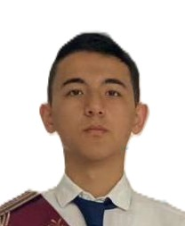

RESUME — IT DEPARTMENT
Abdulla Muxtorov  IT and AI Specialist | 📞 +998 99 877 60 19  ✉️ abdullamuxtorov2008@mail.ru  📍 Location: Uzbekistan, Tashkent
■ PROFILE SUMMARY
Highly motivated IT enthusiast with strong interest in backend development, cybersecurity, and AI programming. Known for fast learning, and efficiency. Able to work independently and in teams, focused on clean and maintainable code.
■ SKILLS
• Python  • JavaScript  • Linux basics  • Git & GitHub | • HTML/CSS  • Telegram bots  • Debugging & Testing  • Problem Solving

■ EXPERIENCE
Company Name — “Worked for gaining experience in Texnik Jixatdan Tratibga Solish Agentligi”
• Assisted to complete tiny projects in that company
• Created my own website using AI, HTML/CSS/JavaScript
• Collaborated with that company members who woks in IT department
■ PROJECTS
Project Name — Portfolio
Created my own portfolio, but not fully. I am currently working on it.
Project Name — Telegram bots
Created Telegram bot for book searching but unfortunately lost all data

■ EDUCATION
Studying in private school named “DONOO School”
Visiting courses related to math and physics
Also acquiring knowledge about cybersecurity, IT and AI from Google company course
Learning how to create useful Telegram bots

■ LANGUAGES
English — B2 (IELTS 6.5)
Russian — C1 (свободное общение)
Uzbek — Native

